Laying the Groundwork: An Introduction to Early Natural Language Processing 2
Objective 2
Introduction 2
What is Natural Language Processing (NLP) and Why is it Important? 2
Natural Language Understanding (NLU) and Natural Language Generation (NLG): A Symbiotic Relationship 3
The Interconnection 4
The Evolution of NLP Techniques 5
Early Natural Language Processing (NLP) Techniques 5
The Evolution from Statistical Models to Neural Networks 8
Conclusion 9
A Journey Through Time: The History of Large Language Models 10
Objective 10
Introduction 10
Artificial Neural Networks: The Foundation 10
Recurrent Neural Networks (RNNs): An Early Attempt at Sequential Data 12
Long Short-Term Memory (LSTM): Addressing Long-Range Dependencies 15
Gated Recurrent Units (GRUs): A Simplified Alternative 15
The Encoder-Decoder Paradigm: A Framework for Sequence Tasks 16
The Bottleneck Problem: Limitations of the Fixed Context Vector 17
The Innovation of Attention: Focusing on What Matters 18
Transformers: Attention is All You Need 19
Conclusion 21
LLMs: The Brains Behind Intelligent Agents 22
The Role of LLMs in Perception, Reasoning, and Action 23
Conclusion 23

Laying the Groundwork: An Introduction to Early Natural Language Processing

Objective
Discover the origins of Natural Language Processing! Explore early attempts to make machines understand language, from simple rule-based systems to the first neural sparks. See how these efforts led to today’s sophisticated Large Language Models (LLMs). Ready to explore the roots of AI text processing?

Introduction
The remarkable capabilities of modern Large Language Models (LLMs) did not emerge overnight. They are the result of decades of research and innovation in the field of natural language processing (NLP). Understanding their history is crucial to appreciating their potential and anticipating their future trajectory. Let's embark on a journey through time, exploring the key milestones that have shaped the evolution of LLMs.

What is Natural Language Processing (NLP) and Why is it Important?
Natural Language Processing (NLP) is a branch of artificial intelligence that focuses on enabling computers to understand, interpret, and generate human language. It bridges the gap between human communication and machine understanding, allowing computers to process and analyze large volumes of text and speech data.
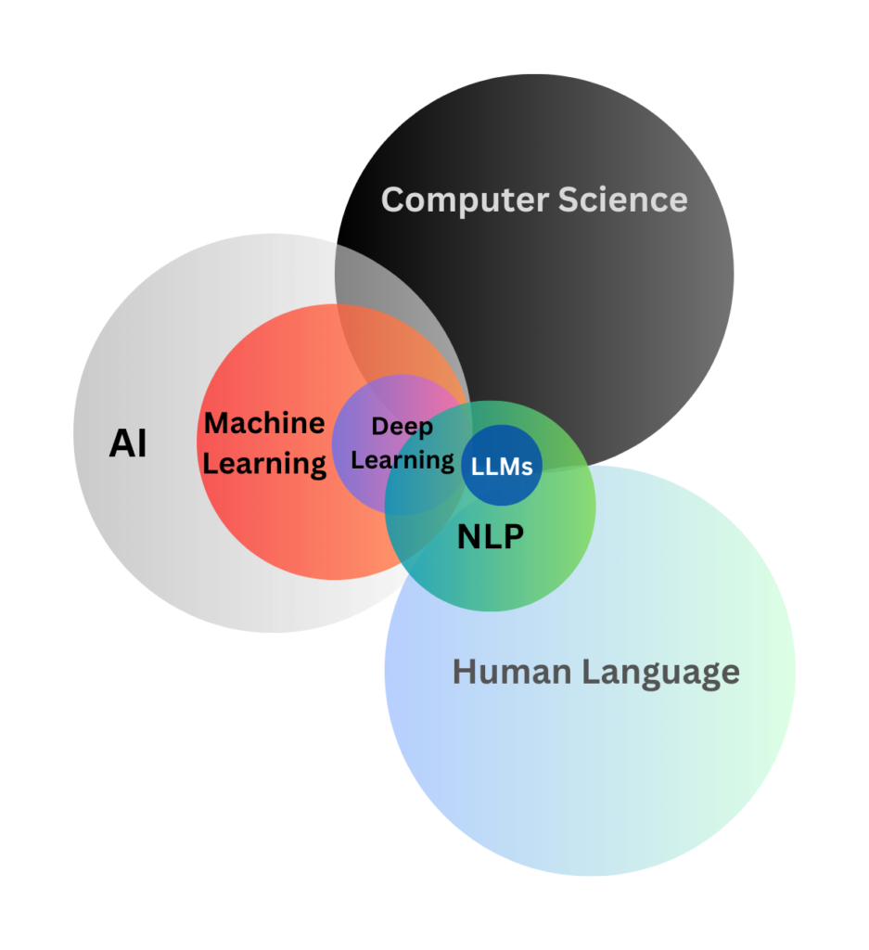
The importance of NLP lies in its ability to unlock the vast amount of information contained within human language. By enabling machines to understand and interact with language, NLP opens up a world of possibilities for automation, communication, and knowledge discovery.

Natural Language Understanding (NLU) and Natural Language Generation (NLG): A Symbiotic Relationship
Natural Language Processing (NLP) is broadly divided into two main components: Natural Language Understanding (NLU) and Natural Language Generation (NLG). While they represent distinct processes, they are deeply interconnected and often work in tandem to enable sophisticated language-based interactions.
- Natural Language Understanding (NLU):
  - NLU focuses on enabling computers to comprehend the meaning and intent behind human language. It involves tasks such as parsing sentences, understanding context, and extracting relevant information.
  - Examples of NLU applications include:
    - Sentiment Analysis: Analyzing customer reviews to determine their emotional tone (e.g., positive, negative, neutral).
    - Intent Recognition: Identifying the user's goal in a query (e.g., "book a flight to London" indicates the intent to make a travel reservation).
    - Entity Extraction: Identifying and classifying named entities in text (e.g., names of people, organizations, locations).
    - Question Answering: Understanding a question and retrieving or generating an appropriate answer.
- Natural Language Generation (NLG):
  - NLG focuses on enabling computers to generate human-like text that is coherent, contextually relevant, and grammatically correct.
  - Examples of NLG applications include:
    - Text Summarization: Generating concise summaries of lengthy documents.
    - Machine Translation: Producing translations that are fluent and natural-sounding.
    - Content Generation: Creating articles, reports, or even creative writing based on input data.
    - Chatbot Responses: Generating natural and engaging responses in conversational interactions.
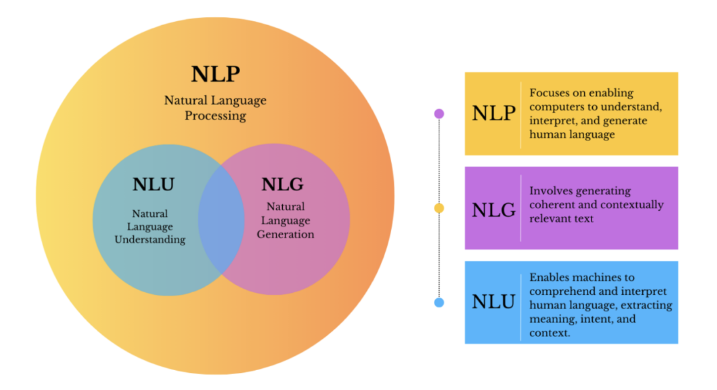

The Interconnection
NLU and NLG form a symbiotic relationship, where the output of one often serves as the input for the other. Essentially, NLU provides the "understanding" that guides NLG's "generation."
- NLU as a Prerequisite for NLG: For a system to generate meaningful and contextually relevant text, it must first understand the input. NLU performs this crucial task, extracting the intent, entities, and relationships from the input text. For example, in a chatbot, NLU analyzes the user's query to determine their intent, which then guides NLG in generating an appropriate response.
- NLG as a Reflection of NLU: The quality and coherence of NLG output depend heavily on the accuracy and depth of NLU's understanding. If NLU misinterprets the input, NLG will produce irrelevant or nonsensical text. For example, in a machine translation system, accurate NLU of the source language is essential for NLG to generate a fluent and accurate translation in the target language.
- Iterative Interaction: In conversational AI, NLU and NLG work iteratively, with each turn building upon the previous interaction. NLU analyzes the user's response, and NLG generates a follow-up question or statement, creating a dynamic and engaging dialogue.
In essence, NLU and NLG are two sides of the same coin, working together to enable machines to communicate with humans in a natural and intuitive way.

The Evolution of NLP Techniques
The earliest attempts at NLP focused on enabling computers to process and understand human language through rule-based and statistical methods. These techniques, while limited compared to modern LLMs, laid the groundwork for future advancements.

Early Natural Language Processing (NLP) Techniques
The roots of NLP can be traced back to the mid-20th century, with early attempts to create machines that could understand and generate human language. These early efforts focused on rule-based systems and statistical methods.
- Rule-Based Systems: These systems relied on manually crafted rules, typically in the form of if-then statements, to analyze and generate language. They were limited by their inability to handle the complexity and variability of human language.
Linguists and programmers would define grammatical rules, syntactic structures, and semantic interpretations for specific language tasks. For example, a rule might specify how to identify the subject and verb in a sentence.
They had several limitations:
  - They were highly brittle and struggled with the inherent ambiguity and variability of human language.
  - Scaling these systems to handle large vocabularies and complex sentence structures was extremely difficult.
  - They required extensive manual effort and domain-specific knowledge.
Typical examples of these systems are early machine translation systems, simple chatbots that relied on predefined patterns.
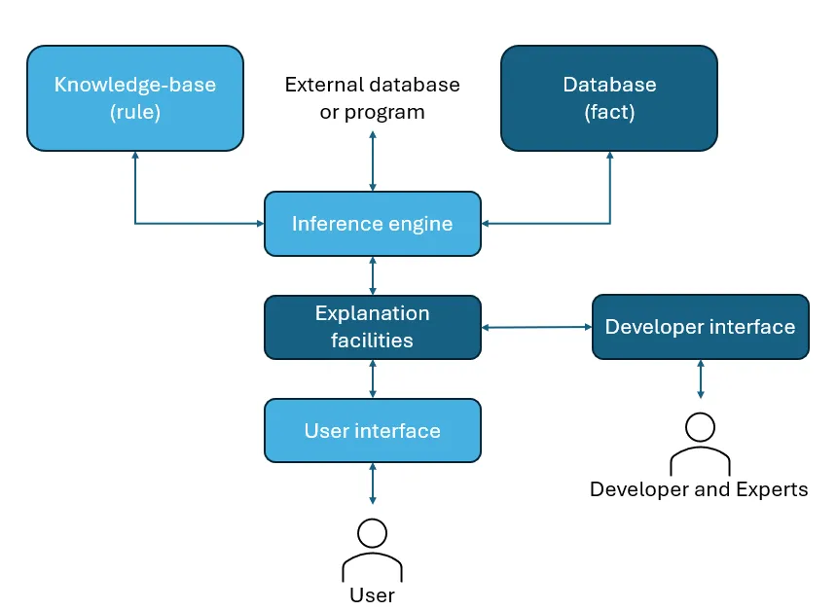
- Symbolic AI (Knowledge Representation): Symbolic Artificial Intelligence (AI) is a subfield of AI that focuses on the processing and manipulation of symbols or concepts, rather than numerical data. The goal of Symbolic AI is to build intelligent systems that can reason and think like humans by representing and manipulating knowledge and reasoning based on logical rules. The process worked as follow:
  - Knowledge Representation: Symbolic AI relied on creating explicit representations of knowledge using formal languages and data structures. Among these representations we can find:
    - Semantic Networks: These represented relationships between concepts using nodes and labeled arcs. For example, "dog" might be connected to "mammal" through an "is-a" relationship.
    - Ontologies: These were formal representations of knowledge in a specific domain, defining concepts, relationships, and constraints. They aimed to provide a structured and unambiguous representation of knowledge
  - Inference Engines: Once knowledge was represented symbolically, inference engines were used to apply logical rules and derive new knowledge.
    - Rule-Based Systems: These systems used if-then rules to perform reasoning. For example, "If X is a dog, then X is a mammal."
    - Logic Programming: Languages like Prolog were used to implement logical reasoning and query knowledge bases.

Common implementation of Symbolic AI included:
  - Parsing: Symbolic AI was used to parse sentences by applying grammatical rules and syntactic structures.
  - Semantic Interpretation: Systems attempted to derive the meaning of sentences by mapping words and phrases to symbolic representations.
  - Question Answering: Knowledge bases and inference engines were used to answer questions based on stored knowledge.
  - Early Machine Translation: Some early machine translation systems used rule-based approaches to translate sentences based on grammatical rules and dictionaries.
Despite having some useful utility, these systems had huge limitations as well:
  - Knowledge Acquisition Bottleneck: Creating comprehensive and accurate knowledge representations for natural language was extremely challenging and time-consuming.
  - Vagueness and Ambiguity: Natural language is inherently vague and ambiguous, which made it difficult to represent using formal symbols and rules.
  - Scalability: Symbolic AI systems struggled to scale to handle large vocabularies and complex sentence structures.
  - Lack of Robustness: These systems were brittle and could easily break when faced with unexpected input or variations in language.
  - Difficulty with Learning: Symbolic AI systems relied on manually encoded knowledge and lacked the ability to learn from data.
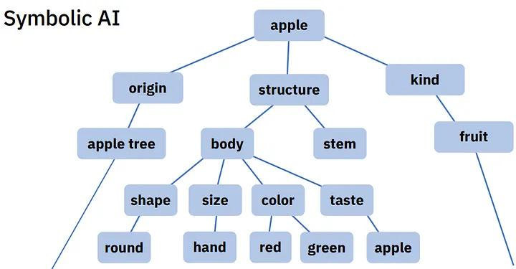

- Statistical Models: These models used statistical techniques to predict the probability of the next word in word sequences, given the words that precede it. They were based on large text corpora and were more robust than rule-based systems, but still struggled with long-range dependencies and context.
Among the main ones we can find:
  - N-grams: These models calculated the probability of word sequences by counting the frequency of n-word combinations in a training corpus. For example, a trigram model would predict the probability of a word given the two preceding words.
  - Hidden Markov Models (HMMs): HMMs were used for tasks like part-of-speech tagging and speech recognition. They modeled language as a sequence of hidden states, with each state generating a probability distribution over words.
  - TF-IDF (Term Frequency-Inverse Document Frequency): This technique was used for information retrieval and text summarization. It assigned weights to words based on their frequency in a document and their inverse frequency across a corpus.
Even though they were an improvement over rule-based systems, they also presented several limitations:
- They relied on shallow statistical patterns and struggled to capture long-range dependencies and semantic meaning.
- They required large amounts of training data to achieve reasonable performance.
- They often lacked the ability to understand context.
Among the examples of these statistical models we can find early spam filters, information retrieval systems, part-of-speech taggers.

The Evolution from Statistical Models to Neural Networks
The late 20th and early 21st centuries marked a significant transition in NLP, moving from reliance on statistical models to the adoption of neural networks. This shift was driven by the increasing availability of computational power and the realization that neural networks could learn more complex patterns and representations of language.
As mentioned, statistical models struggled to capture deeper semantic meaning or long-range dependencies in text and often treated words in isolation, failing to capture the context in which they appeared.
Neural networks, inspired by the structure of the human brain, offered a more flexible and powerful approach to NLP.
- Distributed Representations: Neural networks represented words and phrases as dense vectors, capturing semantic relationships in a continuous vector space. This allowed for more nuanced and flexible representations compared to symbolic or statistical methods.
- Automatic Feature Learning: Unlike statistical models that relied on manually engineered features, neural networks could automatically learn relevant features from the data.
- Ability to Capture Long-Range Dependencies: Neural networks, particularly Recurrent Neural Networks (RNNs), showed promise in capturing long-range dependencies in sequential data like text.

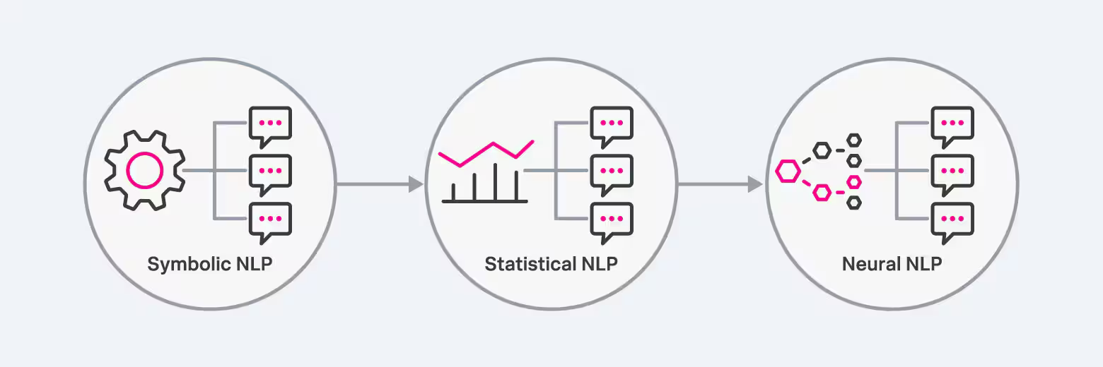

Conclusion
This exploration of the early stages of NLP reveals a progression from rule-based and statistical methods to the dawn of neural networks. Each phase contributed crucial insights and techniques, ultimately paving the way for the sophisticated language models we see today. The shift to neural networks, with their ability to learn complex representations and capture long-range dependencies, marked a turning point. But the story doesn’t end here. How exactly did these initial neural architectures evolve to handle the complexities of language with increasing proficiency? What specific types of neural networks emerged and what key innovations propelled us closer to the powerful Large Language Models that drive intelligent agents? Join us in the next chapter of our journey, ‘A Journey Through Time: The History of Large Language Models‘ as we delve deeper into the rise of recurrent networks and the architectural advancements that followed.

A Journey Through Time: The History of Large Language Models

Objective
Neural networks take center stage! Follow the evolution of Large Language Models, from early sequence learning to the pivotal rise of recurrent architectures and attention. Discover the key innovations that paved the way for the intelligent agents of today. Ready for a history lesson that rewrites the future?

Introduction
In the realm of Agentic AI, where systems autonomously perceive, reason, and act, Large Language Models (LLMs) stand as the core intelligence driving these capabilities. They are the "brains" that enable agents to understand and generate human-like text, interpret complex instructions, and even engage in sophisticated reasoning. But what exactly are LLMs, and how do they function as the linchpin of intelligent agents?

Artificial Neural Networks: The Foundation
At the core of LLMs, and indeed most modern AI, are Artificial Neural Networks (ANNs). These are computational models inspired by the structure and function of biological neural networks (image a). ANNs consist of interconnected nodes, or "neurons," organized in layers. Each connection between neurons has a weight, which is adjusted during training to optimize the network's performance.
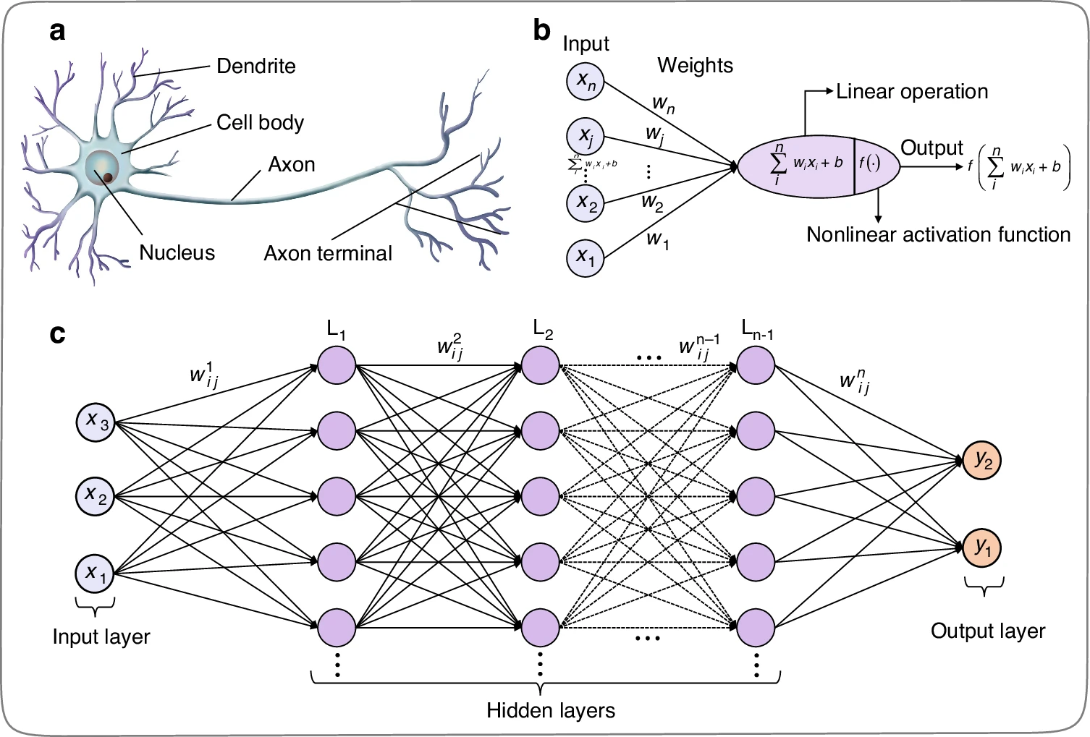
- Layers: ANNs typically have an input layer, one or more hidden layers, and an output layer (image c).
- Neurons: Each neuron receives inputs, applies a mathematical function (activation function), and produces an output (image b).
- Weights: Weights determine the strength of connections between neurons, and are learned through training.
- Activation Functions: These introduce non-linearity, allowing the network to learn complex patterns.
Deep Learning, a transformative subfield of machine learning, leverages ANNs with numerous layers—hence the "deep" aspect—to automatically learn hierarchical representations of data. This ability to extract increasingly abstract features from raw input has enabled ANNs to tackle previously intractable tasks, from image recognition to natural language processing.

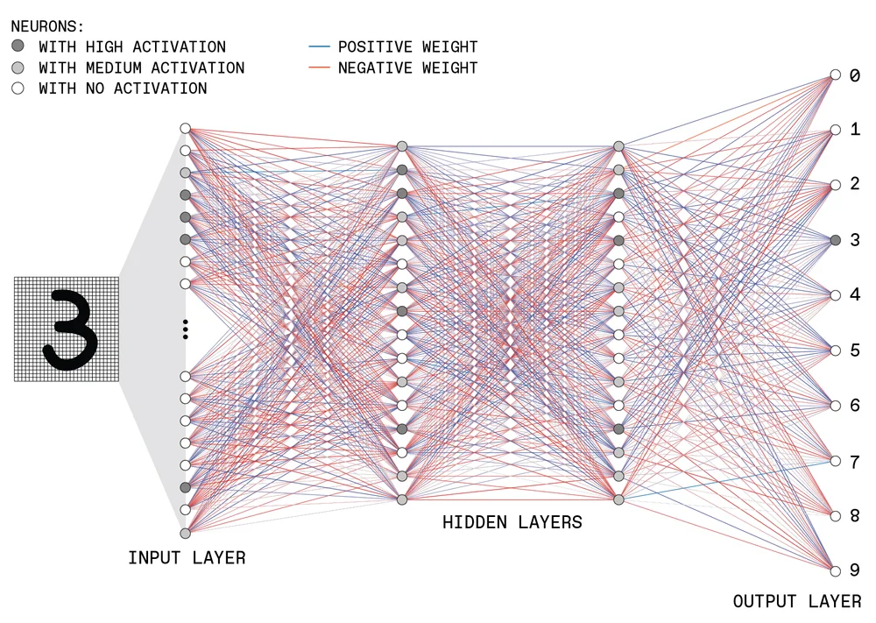

However, traditional deep learning architectures struggled with sequential data like text.

Recurrent Neural Networks (RNNs): An Early Attempt at Sequential Data
Early attempts to process sequential data, such as text, using traditional deep learning architectures encountered limitations. This led to the development of Recurrent Neural Networks (RNNs), which were specifically designed to handle sequences.
- Sequential Processing: RNNs process input sequences one element at a time, maintaining an internal "memory" of past inputs through a hidden state.
- Hidden State: The hidden state acts as a memory, carrying information from previous time steps to the current one.
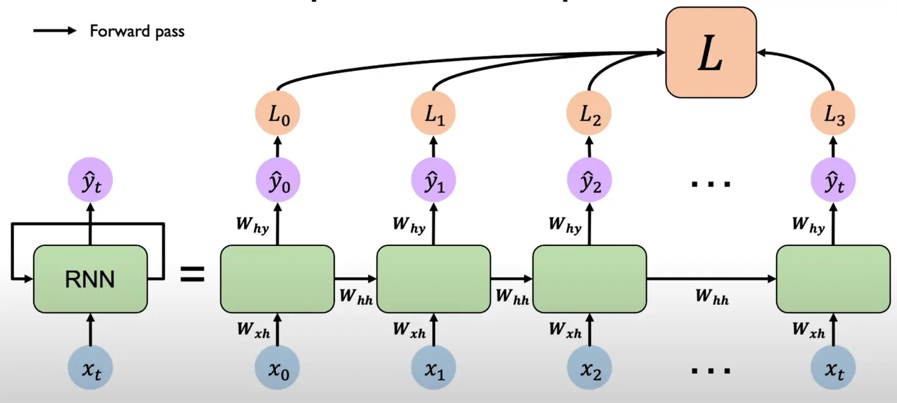
Depending on the problem, different RNN’s architecture can be formed to provide the required solution and applications:
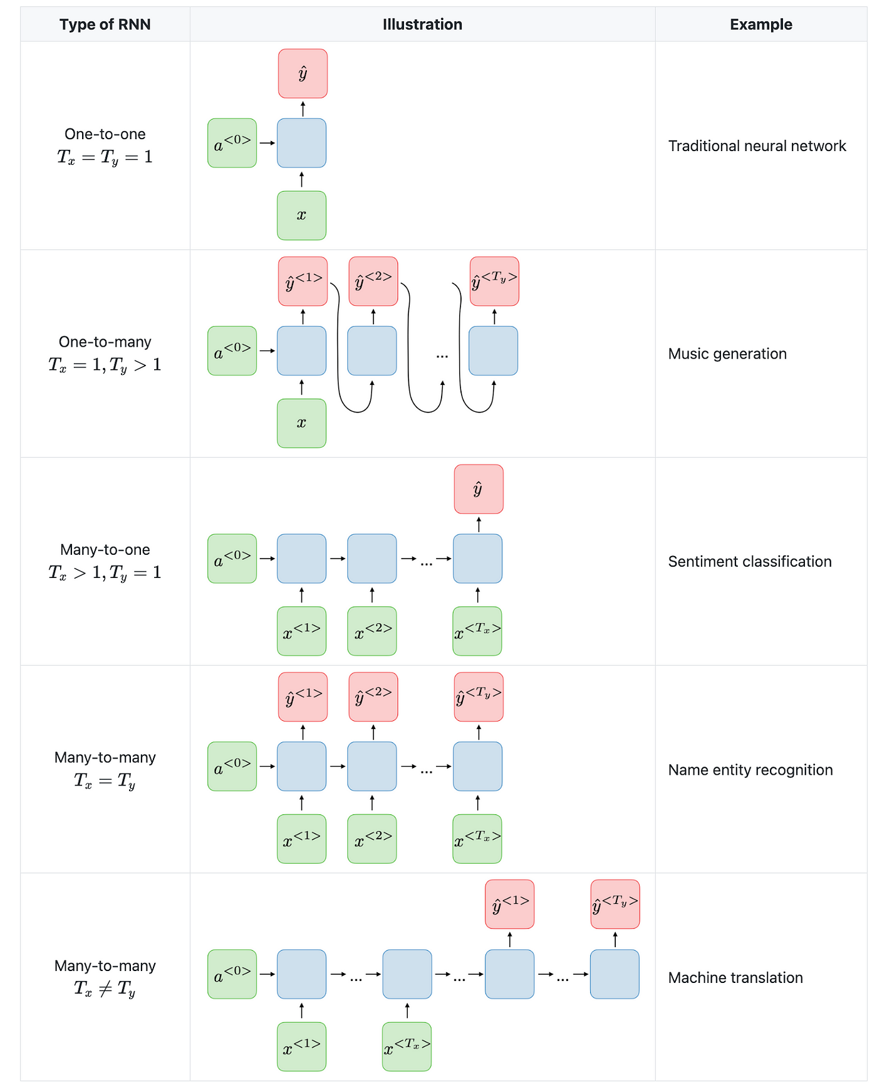
However, RNNs suffered from the vanishing/exploding gradient problem, which hindered their ability to learn long-range dependencies. As the sequence length increased, the gradients used to update the network's weights (a method known as Backpropagation) became smaller/bigger, making it difficult to capture contextual information spanning extended text passages.

Long Short-Term Memory (LSTM): Addressing Long-Range Dependencies
To overcome the vanishing gradient problem and improve the ability to capture long-range dependencies, researchers developed Long Short-Term Memory (LSTM) networks.
- Memory Cells: LSTMs introduce memory cells that can store information over extended periods.
- Gating Mechanisms: LSTMs employ three gating mechanisms—forget, input, and output gates—to control the flow of information into and out of the memory cells.
  - Forget Gate: Decides which information should be discarded from the memory cell.
  - Input Gate: Determines which new information should be stored in the memory cell.
  - Output Gate: Controls which information from the memory cell should be used to compute the output.
- Improved Long-Range Dependency Handling: These gates enable LSTMs to selectively remember or forget information, allowing them to capture long-range dependencies more effectively.
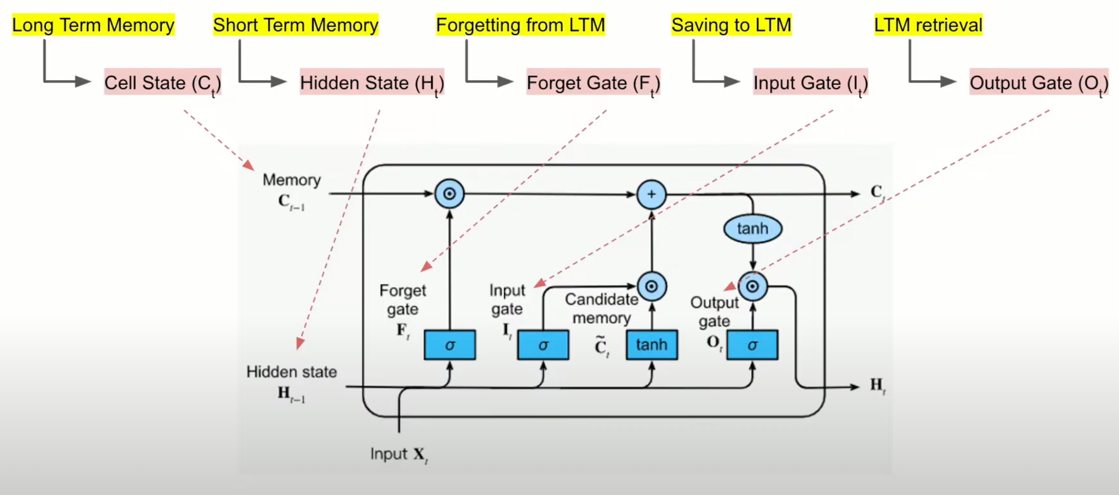

Gated Recurrent Units (GRUs): A Simplified Alternative
Gated Recurrent Units (GRUs) offer a simplified alternative to LSTMs, achieving similar performance with fewer parameters.
- Simplified Gating: GRUs combine the input and forget gates into a single update gate and use a reset gate to control how much past information to consider.
  - Update Gate: Determines how much of the past hidden state to retain and how much of the new input to use.
  - Reset Gate: Controls how much of the past hidden state to ignore.
- Computational Efficiency: GRUs are computationally more efficient than LSTMs due to their simpler structure, making them faster to train and execute.
- Similar Performance: Despite their simplicity, GRUs often achieve performance comparable to LSTMs on many NLP tasks.
Here is how the architecture of the GRU looks like compared to a classic RNN and its LSTM improvement:
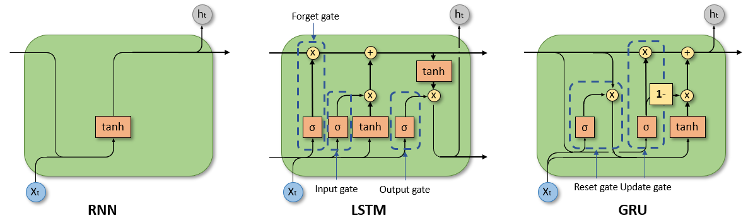

The Encoder-Decoder Paradigm: A Framework for Sequence Tasks
While LSTMs and GRUs represented significant advancements in handling sequential data by mitigating the vanishing gradient problem and improving the capture of long-range dependencies, they were often employed within a broader architectural framework known as the encoder-decoder paradigm. This architecture provided a structure for tackling sequence-to-sequence (seq2seq) tasks, such as machine translation and text summarization, leveraging the strengths of these recurrent units to process and generate sequential information.
- The Encoder: This part of the network takes the input sequence (e.g., a sentence in the source language) and processes it step by step. The goal of the encoder is to condense the entire input sequence into a fixed-length vector, often called the context vector or thought vector. In the context of RNNs, the final hidden state of the encoder (which could be an LSTM or GRU) was typically used as this context vector, aiming to capture a summary of the entire input.
- The Decoder: The decoder then takes this context vector as its initial state and attempts to generate the output sequence (e.g., the translation). It does this step by step, predicting the next word based on the context vector and the words it has generated so far. Like the encoder, the decoder was often implemented using RNNs (LSTMs or GRUs).
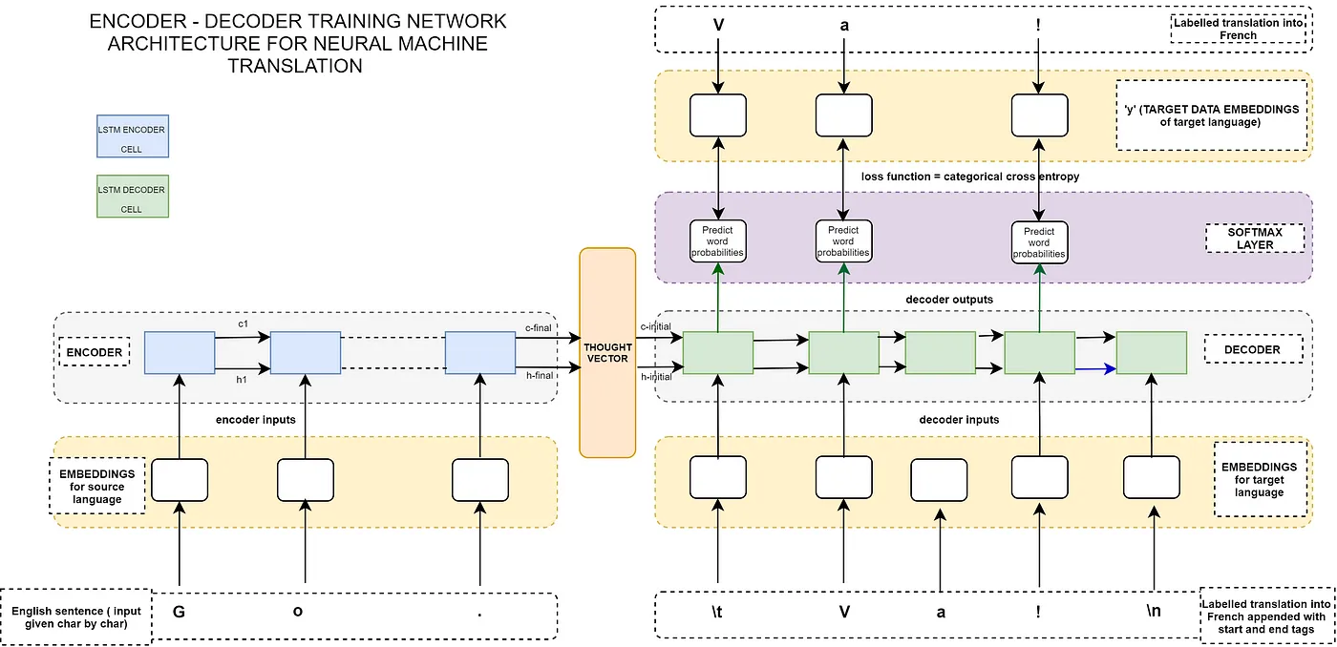

The Bottleneck Problem: Limitations of the Fixed Context Vector
While the encoder-decoder framework was a significant step forward, it encountered a critical challenge, especially when dealing with longer input sequences: the bottleneck problem.
- Information Compression: The encoder is forced to compress all the information from the potentially long input sequence into a single, fixed-size context vector. This is akin to summarizing an entire book in one short paragraph – inevitably, some important details and nuances are lost.
- Difficulty with Long-Range Dependencies: The context vector might struggle to effectively represent relationships between words that are far apart in the input sequence. The information from the beginning of a long sentence might be diluted by the time the encoder processes the end.
- Decoder's Limited Perspective: The decoder has only this single, static context vector to rely on for generating the entire output sequence. It lacks the ability to focus on specific parts of the input that might be particularly relevant at different stages of the output generation process.
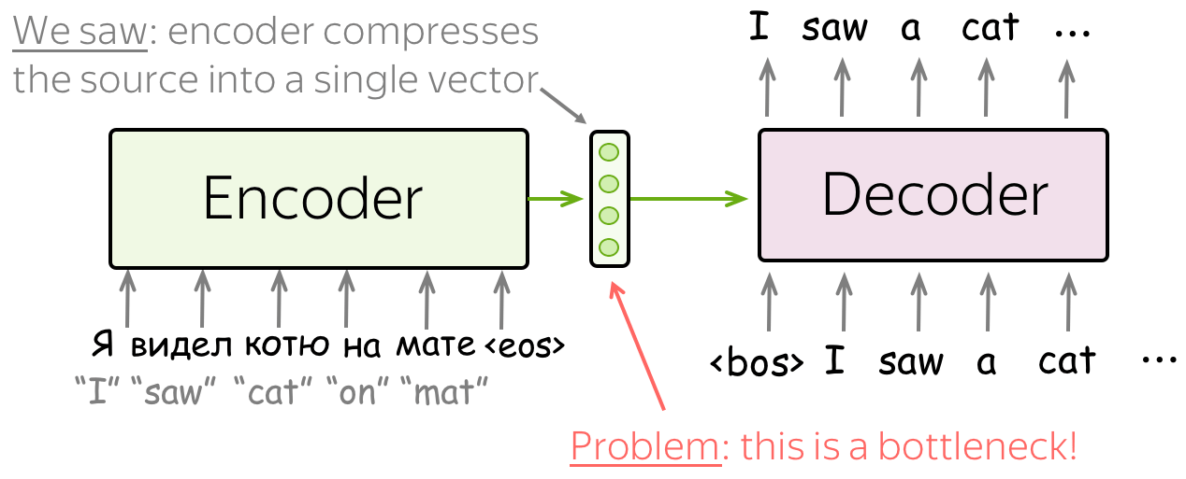

The Innovation of Attention: Focusing on What Matters
To overcome the limitations of the fixed-length context vector and the bottleneck problem, researchers introduced the attention mechanism. It was first introduced in the paper Neural Machine Translation by Jointly Learning to Align and Translate to address the fixed representation problem. The idea is that at different decoder steps, we let the model “focus” on different parts of the input.
- Selective Focus: Attention allows the decoder, at each step of generating the output sequence, to look back at the entire input sequence and selectively focus on the parts that are most relevant to the current output it's trying to produce.
- Dynamic Context: Instead of a single, fixed context vector, attention mechanisms enable the decoder to compute a dynamic, weighted context vector. This vector is a combination of the encoder's hidden states, where the weights indicate the importance of each part of the input for the current decoding step.
- Improved Performance: By allowing the decoder to attend to the relevant parts of the input, attention mechanisms significantly improved the performance of encoder-decoder models, especially for longer sequences, leading to more accurate and coherent outputs.
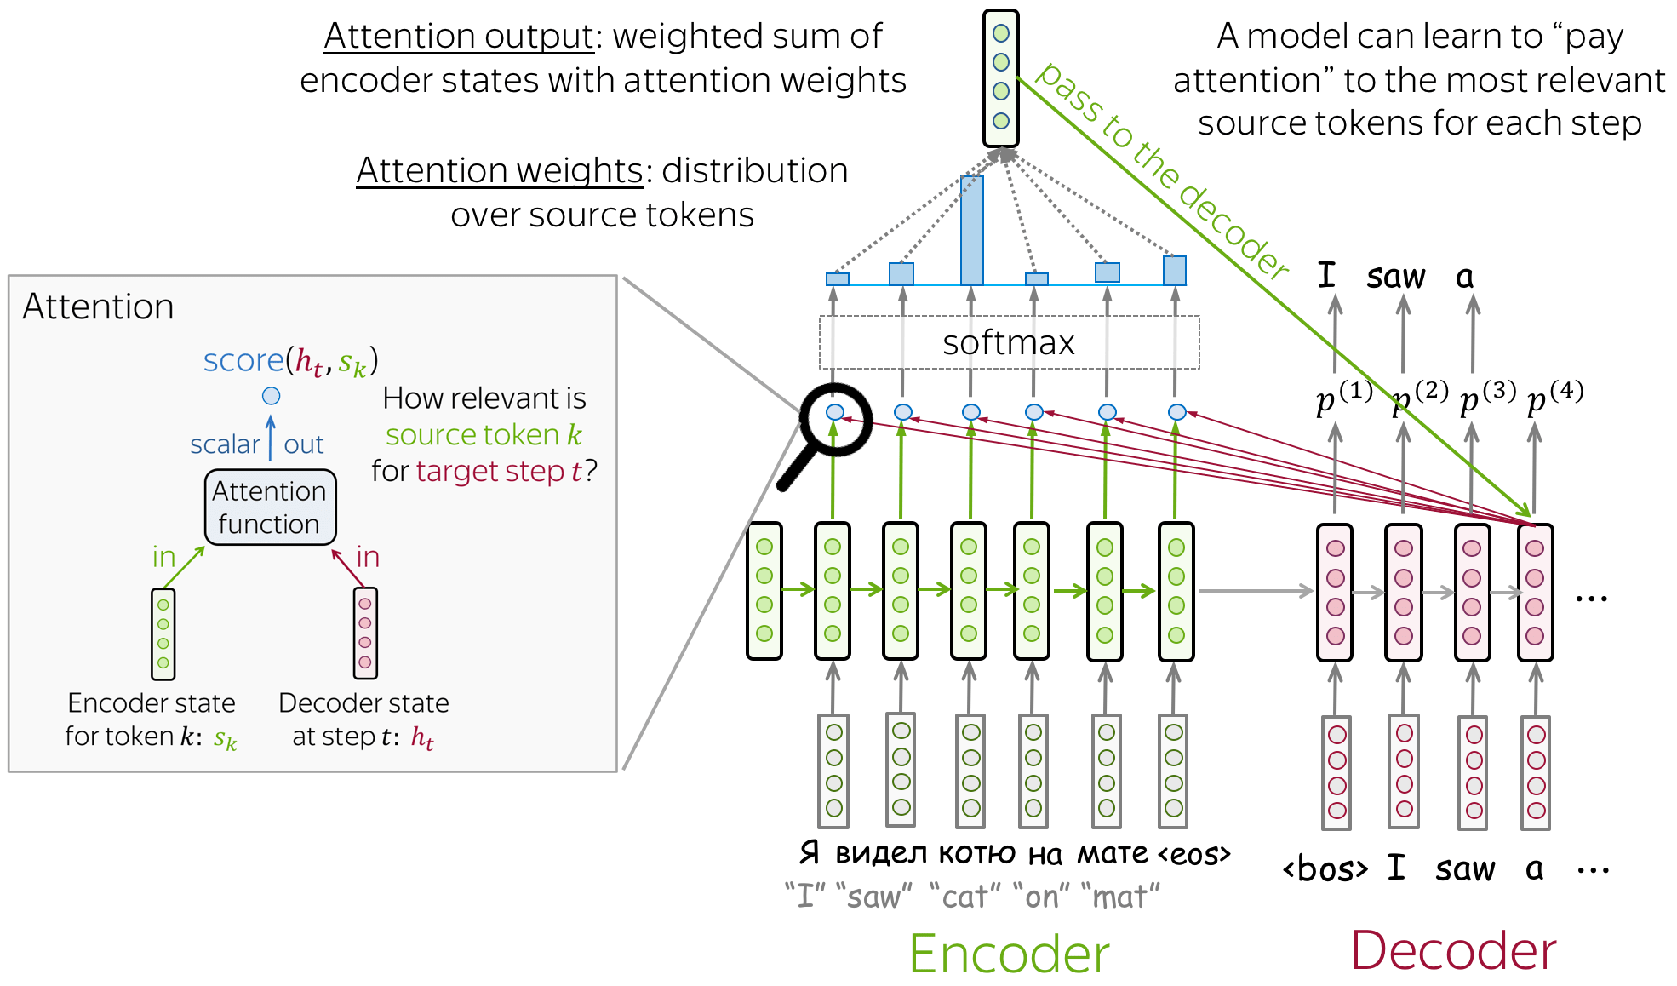

While the introduction of attention mechanisms significantly improved the performance of encoder-decoder models, particularly for longer sequences, these architectures still often relied on underlying recurrent structures (like LSTMs or GRUs) for processing the input and output sequences. This inherent sequential processing limited parallelization and could still struggle with capturing very long-range dependencies effectively. Moreover, the attention mechanism was primarily used by the decoder to focus on the encoder's output. The Transformer architecture, however, took the power of attention to an entirely new level by dispensing with recurrence altogether and making attention the central building block for both encoding and decoding, allowing for parallel processing and direct modeling of relationships within the input and output sequences themselves.

Transformers: Attention is All You Need
The introduction of attention mechanisms was a pivotal step. It demonstrated the power of allowing the model to selectively focus on different parts of the input. Building upon this crucial idea, the Transformer architecture emerged, taking the concept of attention to a whole new level. The original architecture for Transformers was first introduced in 2017 in the paper Attention is All You Need.
The evolution from traditional ANNs to Transformers marked a significant leap in handling sequential data, since Transformers process input data in parallel, enabling them to capture long-range dependencies efficiently. Unlike RNN-based encoder-decoder models where attention was an add-on, the Transformer architecture is built entirely on attention mechanisms, most notably self-attention, which allow the model to weigh the importance of different parts of the input when generating output.

- Self-Attention: This mechanism enables the model to understand the relationships between different words in a sentence. It calculates attention scores, indicating how much each word should "pay attention" to other words. This eliminates the need for recurrence and enables parallel processing of the input.
- Multi-Head Attention: To capture diverse patterns, Transformers use multiple attention heads, each focusing on different aspects of the input.
- Feed-Forward Networks: After attention layers, feed-forward networks process the attended information, adding non-linearity to the model.
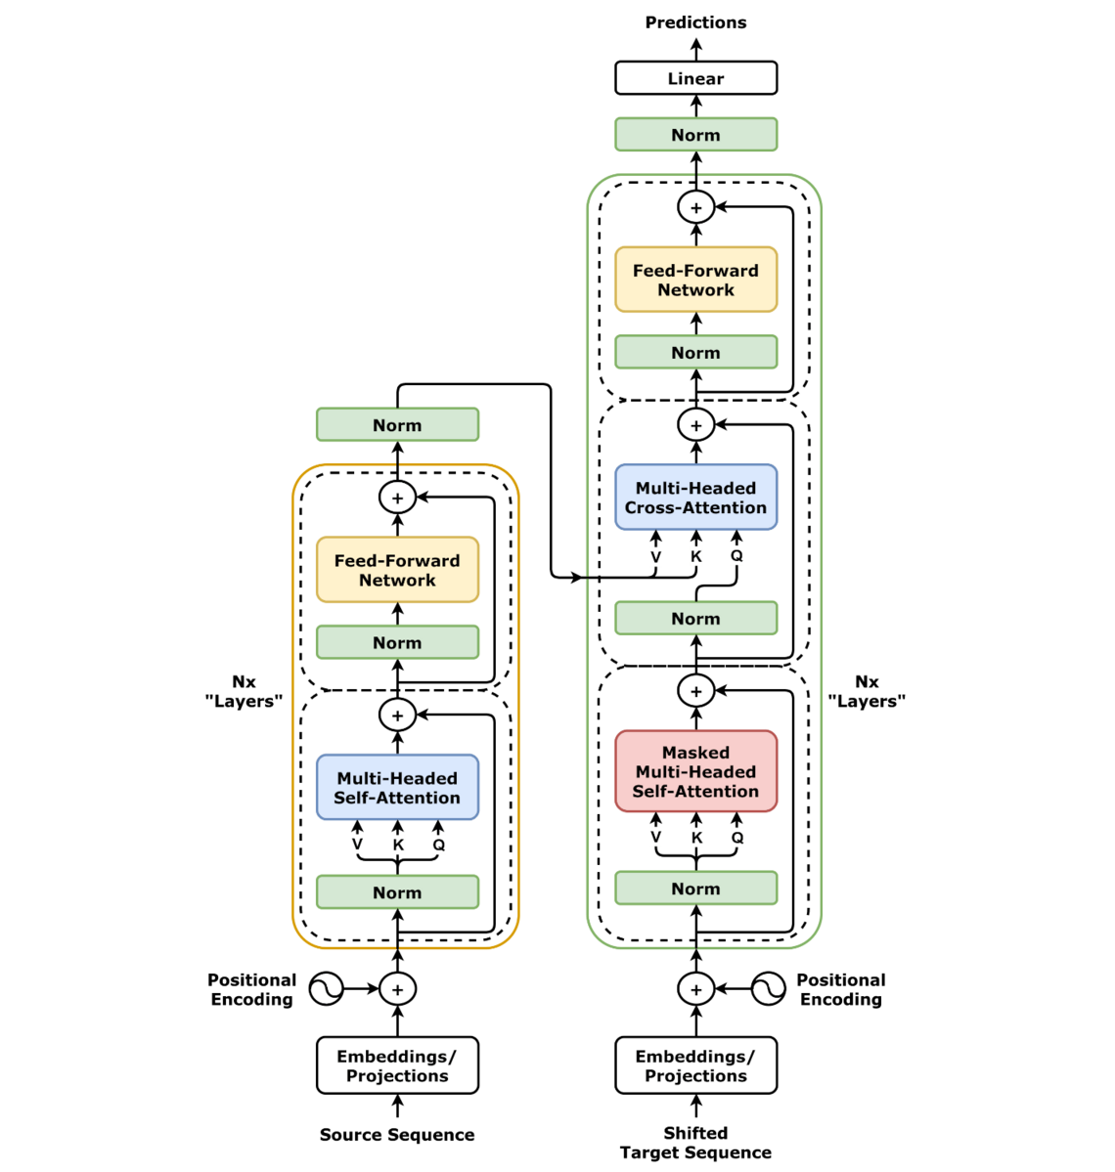
These mechanisms enable LLMs to grasp context, semantics, and even implicit relationships within text, which is essential for perception and reasoning in Agentic AI. As a result, they can comprehend and generate human language with remarkable fluency, making them highly effective at predicting the next word in a sequence with astonishing accuracy.
This predictive power extends beyond mere word generation. LLMs learn to understand the context, nuances, and even the underlying intent of language. They can summarize lengthy documents, answer complex questions, and even generate creative content, all by leveraging their vast knowledge base and sophisticated understanding of language structure.

Conclusion
The progression of neural networks for language processing, from the initial promise of RNNs through the advancements of LSTMs and GRUs to the attention-enhanced encoder-decoder framework, marked significant strides in modeling language complexity. Each architectural evolution tackled limitations in sequential processing and long-range dependencies, with attention mechanisms proving particularly transformative by enabling more context-aware AI. These advancements laid crucial groundwork for the next major leap in the pursuit of AI capable of sophisticated language understanding and generation – capabilities essential for driving truly autonomous behavior in Agentic AI systems.
The emergence of the Transformer architecture, built entirely on attention and dispensing with recurrence, represented a paradigm shift. This innovation enabled parallel processing and direct modeling of relationships within sequences, paving the way for the powerful Large Language Models that now underpin much of Agentic AI. To understand how these Transformer-based LLMs achieve the perception, reasoning, and action required for intelligent agents, and to explore the diverse architectures that power them, join us in our next article, 'LLMs: The Brains Behind Intelligent Agents.

LLMs: The Brains Behind Intelligent Agents

Objective
Discover the Transformer architecture at the heart of Large Language Models, the driving force of Agentic AI. Explore its core mechanisms and key variants. We'll also touch on current LLM challenges, setting up future discussions on enhancing these intelligent agents. Ready to understand the intelligence behind these powerful models?

Introduction
Our journey through the history of Large Language Models brought us to the revolutionary Transformer architecture, the foundation of today's most powerful language models and the driving force behind Agentic AI. These LLMs act as the 'brains' of intelligent agents, enabling them to understand, generate, and interact with the world in complex ways. Understanding the Transformer is key to grasping the potential of autonomous AI.
In this article, we'll delve into the core of the Transformer, exploring its fundamental mechanisms and the key architectural variations that have arisen. We'll also briefly address the current limitations of these models. This exploration will lay the groundwork for future discussions on how LLMs are further enhanced to power truly intelligent and autonomous agents.

The Original Transformer Architecture: A High-Level Look
The Transformer architecture, introduced in 2017 by the paper Attention is All You Need, revolutionized sequence processing by moving away from the sequential nature of Recurrent Neural Networks (RNNs). RNNs struggled with long-range dependencies and parallelization. The Transformer's core innovation is self-attention, a mechanism that allows each word in an input sequence to directly attend to all other words, computing a context-aware representation in parallel. This eliminates the sequential bottleneck and enables the model to capture relationships across the entire sequence more effectively.

The self-attention process involves transforming each input word into Query (Q), Key (K), and Value (V) vectors. The relevance between words is determined by the dot product of their Query and Key vectors, which is then used to weight the Value vectors. Multi-head attention further enhances this by performing the self-attention process multiple times with different sets of Q, K, and V transformations, allowing the model to capture diverse relationships within the data. To maintain the sense of sequence without recurrence, positional encodings are added to the input embeddings, providing the model with information about the position of each word.

The original Transformer architecture comprises stacked encoder and decoder layers. The encoder processes the input sequence through multiple layers of self-attention and feed-forward networks. The decoder, responsible for generating the output, has a similar structure but includes an additional attention layer over the encoder's output and a masking mechanism during training to ensure autoregressive generation. Residual connections and layer normalization are used throughout both the encoder and decoder to facilitate training and improve performance.

From Input to Output: Tracing the Transformer's Processing Pipeline
To understand how Large Language Models achieve their remarkable abilities, we need to explore the inner workings of the Transformer architecture. This section will trace the Transformer's processing pipeline, following the journey of text from its initial input to the final generated output. By examining each stage, we'll gain a clearer picture of how this groundbreaking design understands and generates human language.

From Text to Tokens: Preparing the Input
The journey of understanding or generating language for a Transformer (and many other architectures and algorithms that process text) begins with transforming raw text into a format the model can process: a sequence of numerical representations. This initial step is called tokenization.
Imagine you have a sentence like: "The quick brown fox jumps over the lazy dog." The tokenizer breaks this continuous string of characters into discrete units called tokens. These tokens can be words ("The", "quick", "brown", etc.), parts of words (subwords like "jump" and "s" from "jumps"), or even individual characters, depending on the specific tokenization method used.
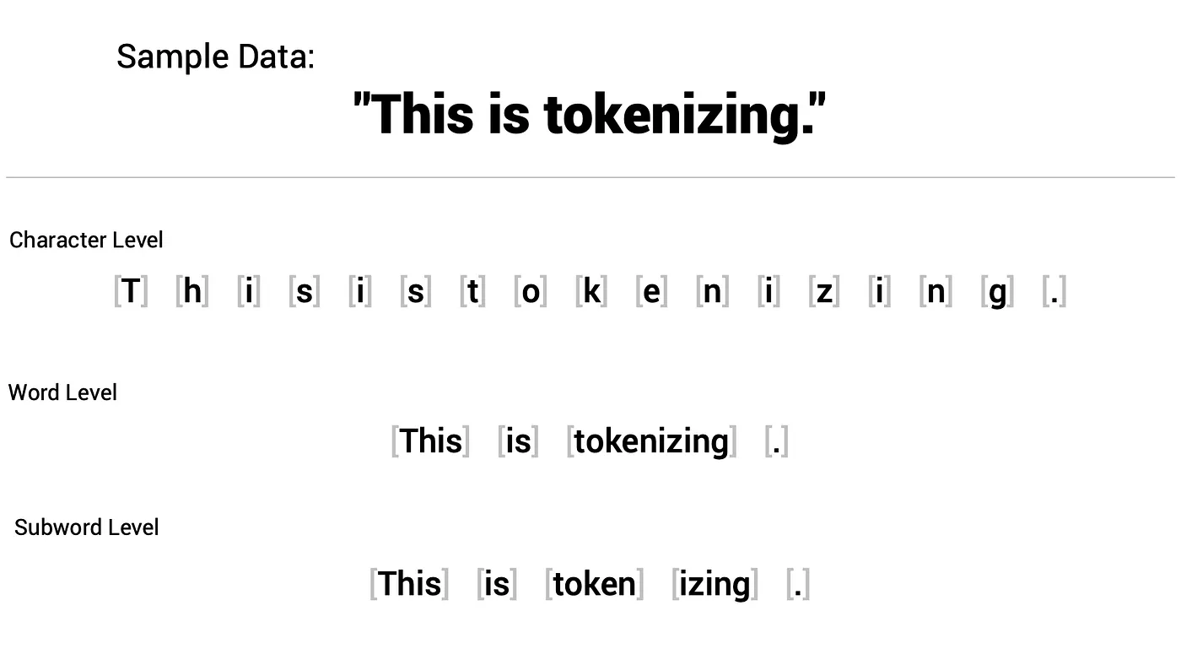
Common tokenization techniques include simple word-based splitting (often based on spaces and punctuation), and more sophisticated subword tokenization methods like Byte-Pair Encoding (BPE) or WordPiece. Subword tokenization is particularly effective in handling large vocabularies and rare or out-of-vocabulary words by breaking them down into smaller, more frequent units. For example, "unbelievable" might be tokenized into "un", "##believ", "##able".

Type | Description | Use Cases
Word Tokenization | Breaks text into individual words. | Effective for languages with clear word boundaries like English.
Character Tokenization | Segments text into individual characters. | Useful for languages without clear word boundaries or tasks requiring granular analysis.
Subword Tokenization | Breaks text into units larger than characters but smaller than words. | Beneficial for languages with complex morphology or handling out-of-vocabulary words.

The output of this stage is a sequence of tokens, ready to be further processed into numerical embeddings.

Embedding the Tokens: Representing Meaning
Once the raw text has been broken down into a sequence of tokens, the next crucial step is to convert these discrete units into a numerical format that the neural network can understand and process. This is achieved through embedding.
During the embedding process, each token is transformed into a dense, low-dimensional vector known as a word (or sentence) embedding. These embeddings are learned during the training process on a massive corpus of text. The key idea behind word (or sentence) embeddings is to capture the semantic meaning and relationships between words (or sentences). Words (or sentences) that are used in similar contexts will have embeddings that are close to each other in the vector space. For instance, the embeddings for "king" and "queen" would likely be closer than the embeddings for "king" and "apple".
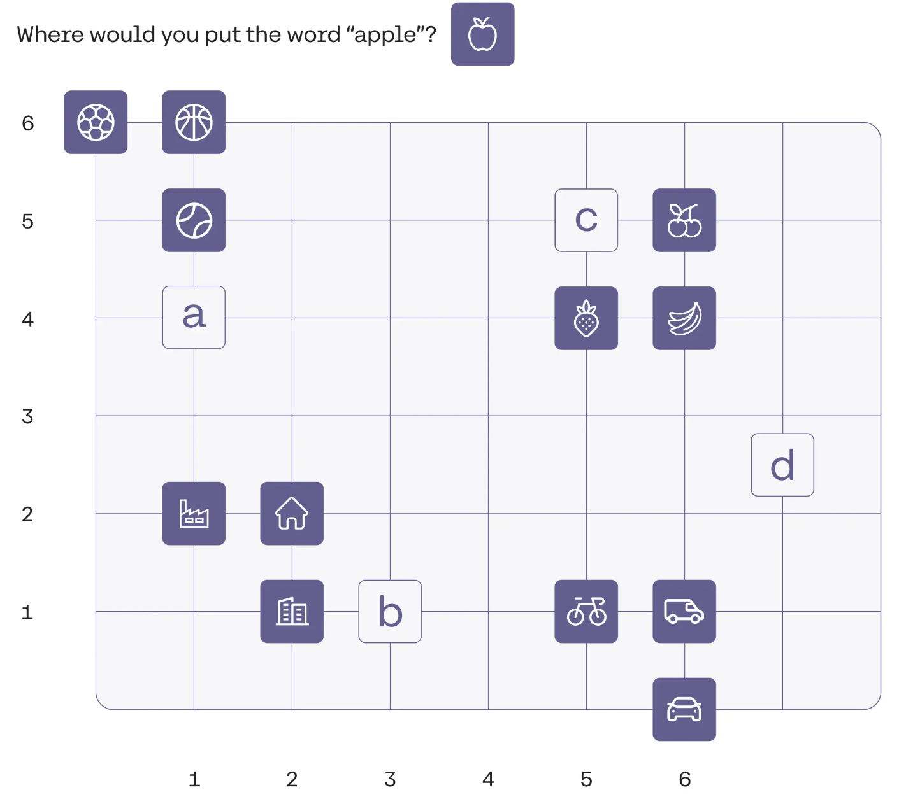
Think of these embeddings as a way of representing the essence of a word in a numerical form, where the numbers in the vector encode different aspects of its meaning and its relationships with other words.
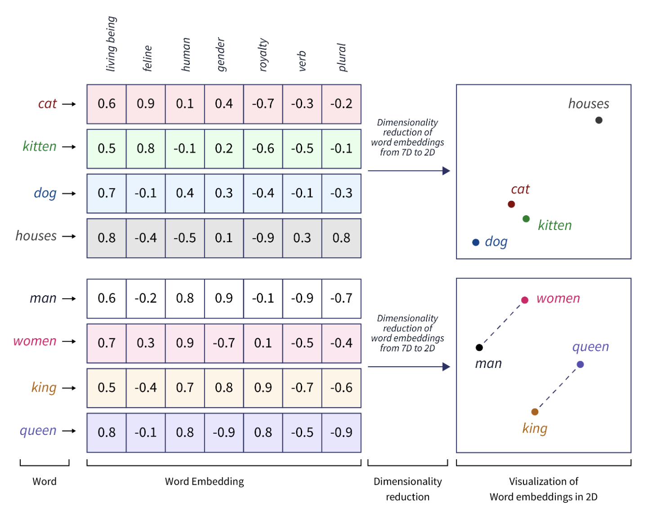

Positional Encoding: Injecting Sequence Information
Because the Transformer processes all tokens in the input sequence simultaneously (unlike RNNs which process sequentially), it loses the inherent information about the order of the words. To address this, positional encodings are added to the word embeddings. These are also vectors, but their values are determined by the position of the token within the sequence. Different positions have unique positional encodings.
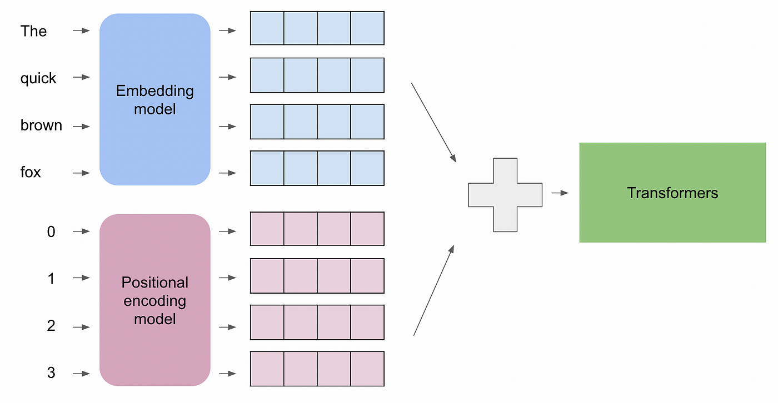
By adding the positional encoding to the word embedding, each token's representation now carries information about both its meaning (from the word embedding) and its location within the sentence. This combined vector is then fed into the subsequent layers of the Transformer encoder.
The Transformer paper proposed a specific method for generating these positional encodings using sine and cosine functions of different frequencies. The key idea behind this choice is that these trigonometric functions allow the model to easily learn relative positions. For any fixed offset k, the positional encoding at position pos+k can be represented as a linear function of the positional encoding at position pos. This makes it easier for the model to attend to words at a certain relative distance.
The formulas used to calculate the positional encoding for a token at position pos and dimension i within the embedding vector are:
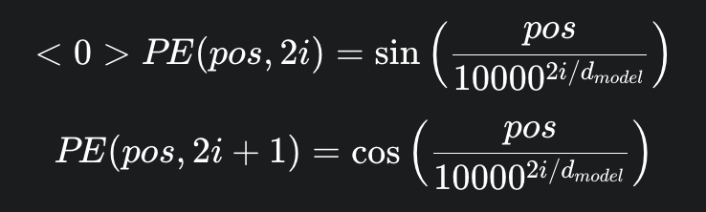
Where:
- pos is the position of the token in the input sequence (starting from 0).
- i is the dimension index within the embedding vector (ranging from 0 to dmodel​/2−1, since 2i and 2i+1 cover all dimensions).
- dmodel​ is the dimensionality of the word embeddings (and thus the positional encodings).
- 10000 is a constant used to scale the frequencies.
Notice that even dimensions of the positional encoding vector are calculated using the sine function, while odd dimensions use the cosine function. The frequency of these sine and cosine waves decreases as the dimension index i increases. This creates a unique "fingerprint" for each position in the sequence.
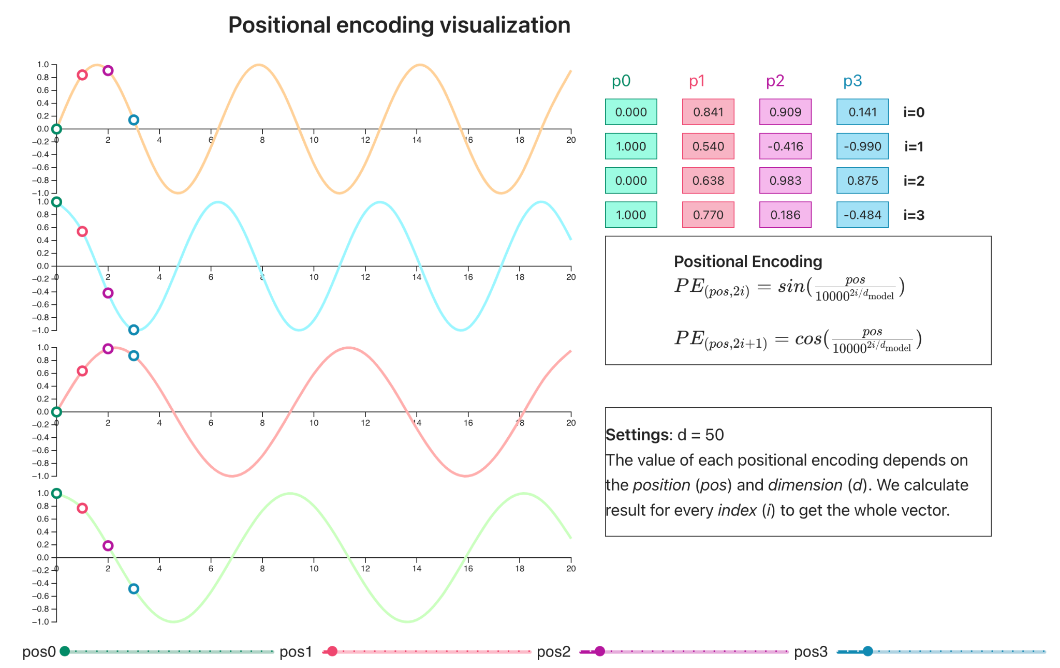
In essence, these sine and cosine waves provide a set of basis functions that allow the model to determine the position of each token. By adding this positional information to the word embeddings, the Transformer can now take into account the order of words while still benefiting from parallel processing.

Entering the Encoder: Understanding the Input Context
With the input text now represented as a sequence of embedded tokens (combining word meaning and positional information), the Transformer embarks on the crucial task of understanding the context of each word within the sequence. This processing happens within the encoder, which is composed of a stack of identical layers. Each encoder layer takes the output from the previous layer (or the initial embeddings in the very first layer) and processes it to produce a more contextually rich representation.
Each encoder layer or transformer block is composed by two major components:
- The Self-Attention component
- The Feed Forward Neural Network component
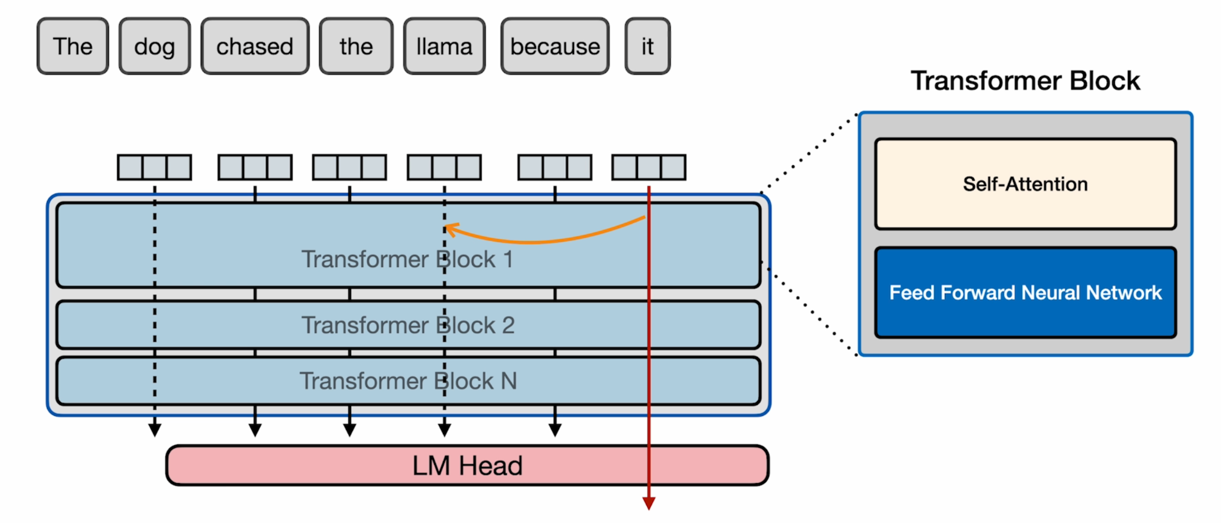

Self-Attention Mechanism: Connecting Words Within the Sequence
In our previous article “A Journey Through Time: The History of Large Language Models”, we introduced the concept of Attention as a mechanism that let the model “focus” on different parts of the input, while processing the output, in an attempt to resolve the bottleneck problem in Encoder-Decoder architectures with RNN’s.
In the Transformer architecture, at the core of the encoder, lies the self-attention mechanism. This crucial component allows each word in the input sequence to directly interact with and understand its relationship to all other words in the same sequence. Instead of processing sequentially, self-attention enables the model to identify which other words are most relevant when interpreting a given word. For instance, consider the following sentence:
The dog chased the llama because it …
Whenever the model is processing the word “it”, some additional information should be provided to the model for it to understand if the word refers to the dog or to the llama. Of course, with just these words it is going to be difficult for the model to know if the word refers to the dog or the llama, but we can assume that in the prompt, there is more contextual information that helps the model with that.
Inside the self-attention component or self-attention head, the transformer does two things:
- Relevance Scoring: it assigns a score to how relevant each of the input tokens are to the token you are currently processing.
- Combining Information: it combines the relevant information into the vector representation of the token to enrich it with context information from other positions.
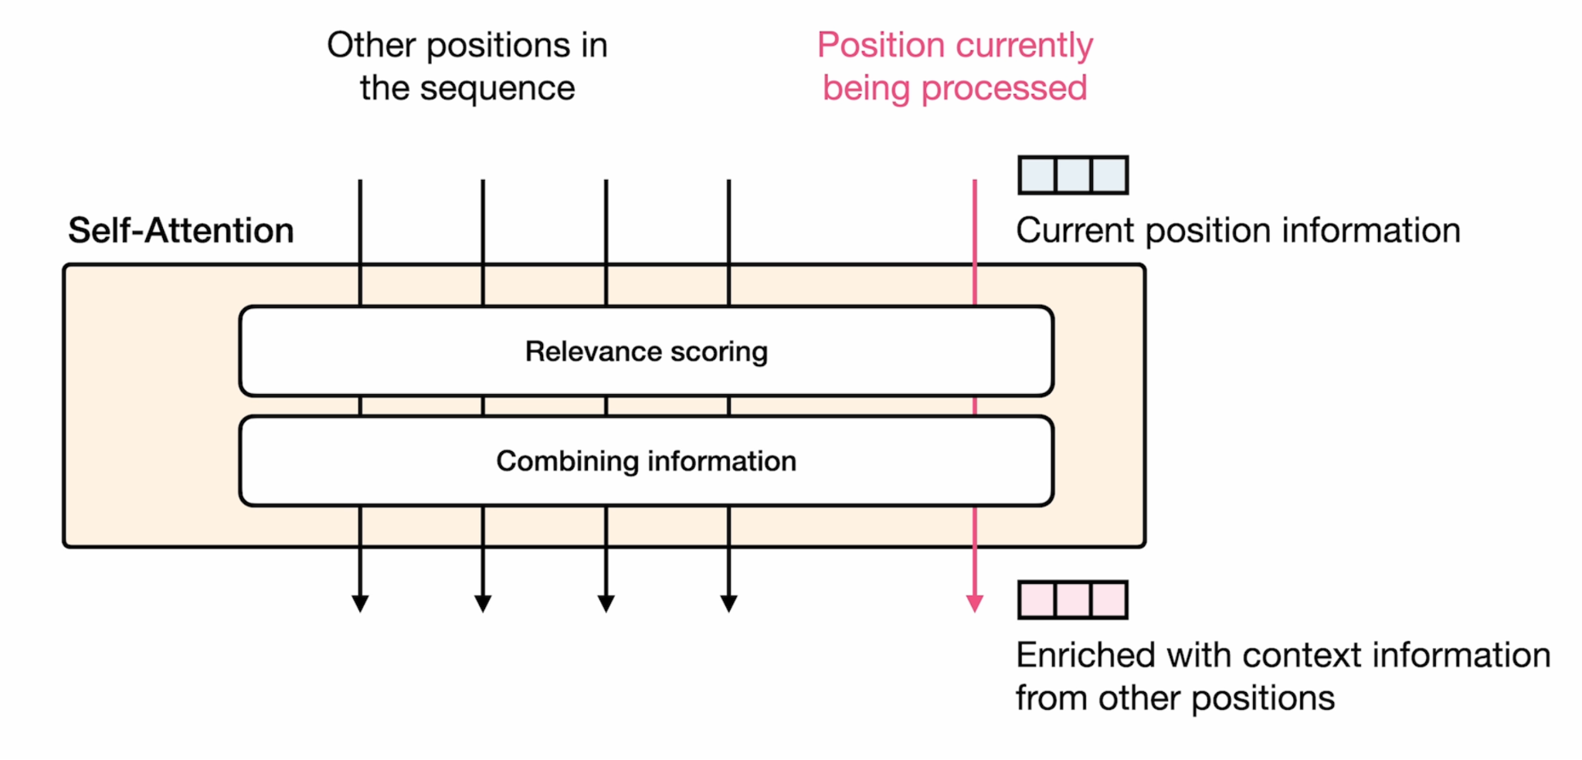
This is achieved through a series of matrix multiplications that calculate attention scores based on the Query (Q), Key (K), and Value (V) vectors derived from the input embeddings. These scores determine the weight each word in the sequence has when contributing to the contextualized representation of the current word.
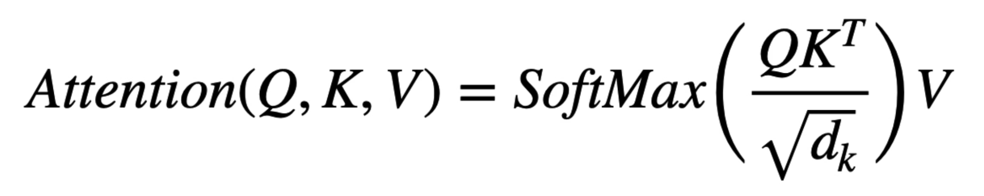
For each input embedding (the combination of word embedding and positional encoding) in the sequence, three different vectors are derived: the Query (Q) vector, the Key (K) vector, and the Value (V) vector. These vectors are obtained by multiplying the input embedding by three different weight matrices that are learned during the training of the Transformer.
Let's say we have an input sequence of embedded tokens X=[x1​,x2​,...,xn​], where each ​ is the embedding vector for the i-th token. To obtain the Query, Key, and Value matrices for the entire sequence, we multiply this input embedding matrix X by three weight matrices: ​, , and . These weight matrices are learned parameters of the Transformer model.


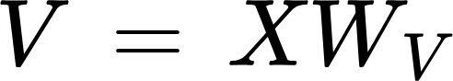

Here:
- X is a matrix where each row corresponds to the embedding of a token in the input sequence. Its shape is (n,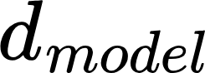​), where n is the sequence length and is the dimensionality of the embeddings.
- ​ (Query weight matrix) has a shape of (​,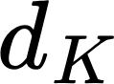​), where ​ is the dimensionality of the Key/Query vectors (often, but not always, equal to ).
- ​ (Key weight matrix) also has a shape of (​,​).
- ​ (Value weight matrix) has a shape of (​,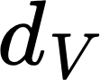​), where ​ is the dimensionality of the Value vectors (can be different from ).
- Q (Query matrix) has a shape of (n,​), where each row 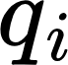​ is the Query vector for the i-th token.
- K (Key matrix) has a shape of (n,​), where each row  is the Key vector for the i-th token.
- V (Value matrix) has a shape of (n,), where each row  is the Value vector for the i-th token.
- The scaling factor 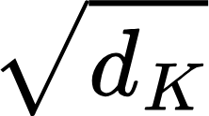 is used to avoid the QK multiplication to become too large
- The SoftMax function is used to convert the real numbers into a probability distribution and get the attention weights.
Without going further into details of this mathematical function for now, the first matrix multiplication (QK) can be seen as a way of finding similarity between tokens. After applying the softmax function we get the mentioned relevance scoring (percentages). When we multiply these percentages by the matrix V, the result is the mentioned combination of information that tells us how much influence each word should have on the final encoding for any given word
.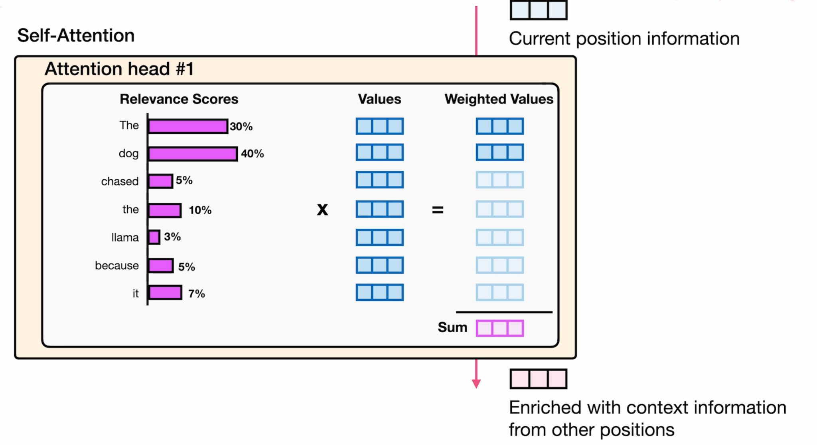
The output of the self-attention mechanism is a set of context-aware embeddings (self-attention scores), where the meaning of each word is now influenced by the entire input sentence.
There is still one more thing to highlight in the attention mechanism. While what was described so far works well, in order to correctly establish how words are related in longer, more complicated sentences and paragraphs, we can apply attention to the encoded Values multiple times simultaneously. This is called multi-head attention.
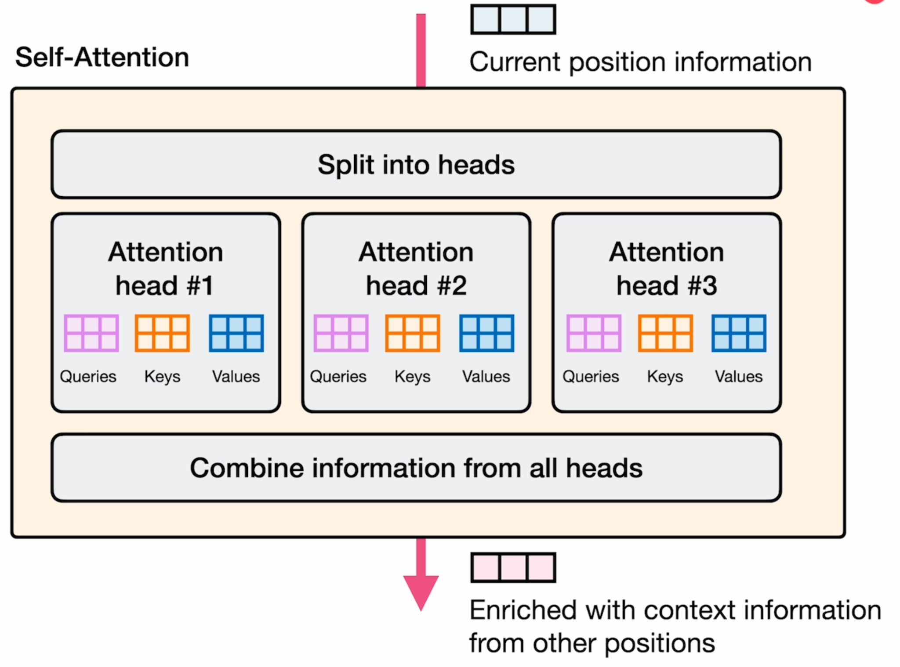
In Multi-Head Attention, the Query, Key, and Value matrices are not just computed once. Instead, for each head, the input embeddings are linearly projected into different Query, Key, and Value matrices using different learned weight matrices (WQi​​,WKi​​,WVi​​ for the i-th head). Each of these "heads" then independently performs the scaled dot-product attention calculation.
Why is it necessary? Think of language as having multiple layers of relationships. A single attention head might focus on grammatical dependencies, while another might capture semantic relationships, and yet another could focus on longer-range contextual links. By having multiple independent attention heads, the Transformer can simultaneously attend to different aspects and representation subspaces of the input sequence. Some heads might excel at identifying syntactic dependencies, while others might be better at capturing semantic similarities or long-range dependencies. This allows the model to gain a richer and more nuanced understanding of the input.
By having multiple parallel attention mechanisms, the model has a higher capacity to learn complex patterns in the data. It's like having multiple experts examining the input from different perspectives, leading to a more comprehensive analysis.
After each of the h attention heads computes its output, these outputs are concatenated along the feature dimension. The concatenated output is then linearly transformed by another learned weight matrix (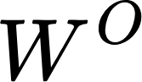​) to produce the final output of the Multi-Head Attention layer, which has the same dimensionality as the original input embedding (or a desired output dimension).
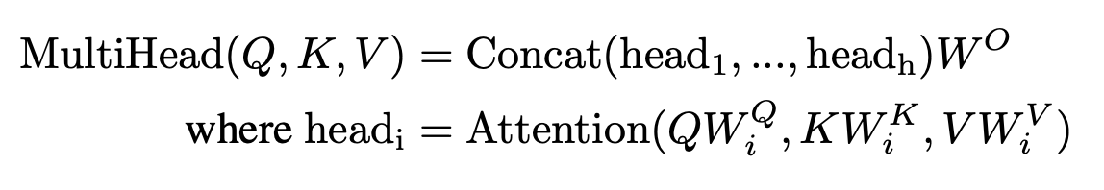
In essence, Multi-Head Attention allows the Transformer to jointly attend to information from different representation subspaces at different positions, significantly enhancing its ability to understand the intricate relationships within language.

- Add & Norm (Residual Connections and Layer Normalization):
  - Explain the concept of residual connections (adding the original input to the output of a sub-layer) and their benefit in preventing vanishing gradients and improving information flow.
  - Describe layer normalization and its role in stabilizing the training process.
- Feed-Forward Network:
  - Explain that after the attention mechanism, each word's representation passes through a feed-forward neural network.
  - Mention that this network is applied independently to each position.
- Repeating Layers: Emphasize that this entire encoder layer process is repeated multiple times, allowing the model to learn increasingly complex representations of the input.
4. The Decoder: Generating the Output Sequence
- Decoder Layer Overview: Briefly introduce the decoder and its similar structure to the encoder, but with added components.
- Masked Self-Attention: Explain that during training (and initial stages of generation), the decoder uses a masked self-attention mechanism to prevent it from "looking ahead" at future tokens in the target sequence.
- Encoder-Decoder Attention: Describe the additional attention layer in the decoder that takes the decoder's previous output and attends over the final output of the encoder. This allows the decoder to focus on the relevant parts of the input when generating the next token.
- Add & Norm and Feed-Forward Network: Mention the presence of these same sub-layers as in the encoder.
- Linear Layer and Softmax (Final Output):
  - Explain that the final output of the decoder stack is passed through a linear layer to project it onto the vocabulary size.
  - Describe how a softmax function is then applied to get probability distributions over the possible next tokens.
  - The token with the highest probability is typically chosen as the next word in the generated sequence.
Conclusion of the Section:
- Briefly summarize the step-by-step process, highlighting the key roles of attention and the encoder-decoder structure.
- Emphasize how this intricate interplay of components allows the Transformer to effectively understand and generate human language.

2. Transformer Variants: Adapting the Foundation
- Encoder-Only Models (e.g., BERT, RoBERTa):
  - Explain their architecture (primarily the encoder stack).
  - Discuss their pre-training objectives (Masked Language Modeling, Next Sentence Prediction, etc.).
  - Highlight their strengths in understanding and representing text for tasks like classification, question answering, and named entity recognition.
- Decoder-Only Models (e.g., GPT family):
  - Explain their architecture (primarily the decoder stack with masking).
  - Discuss their autoregressive nature and pre-training objective (next token prediction).
  - Highlight their strengths in text generation, completion, and conversational AI.
- Encoder-Decoder Models (e.g., T5, BART):
  - Explain their full encoder and decoder structure.
  - Discuss their pre-training objectives (e.g., masked sequence-to-sequence tasks).
  - Highlight their versatility in handling a wide range of sequence-to-sequence tasks like translation, summarization, and question answering.

3. Evolution of the Transformer Architecture: Continuous Improvement
- Briefly touch upon key advancements and modifications to the original Transformer:
  - Handling Longer Contexts: Mention Transformer-XL, Reformer, Longformer, etc., and their core ideas.
  - Efficiency Improvements: Briefly mention techniques like sparse attention and quantization.
  - Incorporating External Knowledge: Briefly mention Retrieval-Augmented Generation (RAG) as a way to enhance LLMs.
  - Scaling and Model Size: Briefly discuss the trend towards larger models and its impact.
4. Current Main Problems and Limitations of LLMs:
- Context Window Limitations (Revisited): Even with advancements, handling extremely long contexts remains a challenge.
- Computational Cost and Efficiency: Training and deploying very large LLMs are resource-intensive.
- Interpretability and Explainability: Understanding why LLMs make certain predictions is difficult.
- Bias and Fairness: LLMs can inherit and amplify biases present in their training data.

- Hallucinations and Factual Inaccuracies: LLMs can generate plausible-sounding but incorrect information.

- Reasoning and Common Sense: While improving, true logical reasoning and common-sense understanding are still areas of active research.
- Control and Alignment: Ensuring LLMs behave as intended and align with human values is crucial.
Conclusion: Looking Ahead in the Age of Intelligent Agents
- Summarize the key aspects of the Transformer architecture and its variants as the driving force behind the current capabilities of LLMs in Agentic AI.
- Reiterate that while LLMs are incredibly powerful, they are not without their limitations, setting the stage for ongoing research and development.
- Smooth Link to Future Articles:
  - "As we've explored, LLMs possess a remarkable ability to understand and generate language, forming the core 'brains' of intelligent agents. However, to truly leverage their potential for autonomous action and complex problem-solving, these language models need to interact effectively with the world and manage information beyond their immediate context."

  - "In our upcoming articles, we will delve deeper into the crucial techniques that enable this interaction and information management. We will explore the power of embeddings in representing semantic meaning, the role of vector databases for efficient information retrieval, the mechanics of Retrieval-Augmented Generation (RAG) in grounding LLM knowledge, the principles of semantic search for finding relevant information, and the diverse tools that allow LLMs to interact with external systems and perform real-world actions. Join us as we continue to unravel the technologies that are shaping the future of Agentic AI."

The Role of LLMs in Perception, Reasoning, and Action
Agentic AI is composed, from a high level perspective, by a couple of key elements, as we saw in a previous article called "Understanding Agentic AI: Core Components Explained". In Agentic AI, LLMs play pivotal roles in each stage of an agent's operation:
- Perception: LLMs process textual inputs (this could be user instructions, data from documents, or information from online sources) by converting them into numerical representations (embeddings). These embeddings capture the semantic meaning of words and phrases. The model then uses its attention mechanisms to understand the context of the input.
- Reasoning: LLMs perform reasoning by generating sequences of tokens that follow logical patterns. Techniques like chain-of-thought prompting guide the model to break down complex problems into smaller, manageable steps.
- Action: LLMs generate text outputs by predicting the next token in a sequence. The model's vast training data and attention mechanisms enable it to produce coherent and contextually relevant text. This can generate human-like text outputs, such as reports, summaries, or even code. This allows agents to communicate their findings, provide instructions, or interact with users in a natural and intuitive way.

Conclusion
The history of LLMs is a testament to the relentless pursuit of creating machines that can understand and generate human language. From early rule-based systems to the sophisticated transformer models of today, each step has brought us closer to realizing the potential of intelligent language processing. Understanding this journey helps us appreciate the current state of LLMs and anticipate the exciting developments that lie ahead. But we must also acknowledge the challenges that lie ahead, which we will discuss in our next article.

